CPE301 – SPRING 2019

MIDTERM II

Student Name: Rocky Yasuaki Gonzalez

Student #: 5003229733

Student Email: gonzar14@unlv.nevada.edu

Primary Github address: https://github.com/rockyg1995/ihswppdar

Directory: https://github.com/rockyg1995/ihswppdar/tree/master/Midterms/Midterm_II

Submit the following for all Labs:

1. In the document, for each task submit the modified or included code (only) with highlights and justifications of the modifications. Also, include the comments.
2. Use the previously create a Github repository with a random name (no CPE/301, Lastname, Firstname). Place all labs under the root folder ESD301/Midterm, sub-folder named LABXX, with one document and one video link file for each lab, place modified asm/c files named as LabXX-TYY.asm/c.
3. If multiple asm/c files or other libraries are used, create a folder LabXX-TYY and place these files inside the folder.
4. The folder should have a) Word document (see template), b) source code file(s) and other include files, c) text file with youtube video links (see template).

1. **COMPONENTS LIST AND CONNECTION BLOCK DIAGRAM w/ PINS**

Atmega328PB Xplained Mini

Micro USB Cable (Power Supply)

Wire Connectors

ADPS-9960

ESP-01

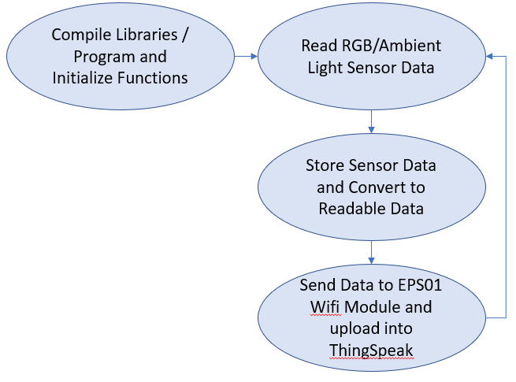

*Figure 1 – Flow Diagram for displaying RGBC Values to ThingSpeak*

1. **INITIAL/MODIFIED/DEVELOPED CODE**

/*

* MIDTERM_II.c

*

* Created: 5/10/2019 11:02:21 PM

* Author: RYG95

*/

#ifndef F_CPU

#define F_CPU 16000000UL

#endif

#include <avr/io.h> /* Include AVR input/output file */

#include <util/delay.h> /* Include delay functions file */

#include <math.h> /* Include math functions file */

#include <stdlib.h> /* Include standard library file */

#include <stdio.h> /* Include standard input/output file */

#include "APDS9960_def.h" /* Include MPU6050 register define file */

#include "i2c_master.h" /* Include I2C Master header file */

#include "uart.h" /* Include USART header file */

#define APDS9960_WRITE 0x72

#define APDS9960_READ 0x73

float C_Light;

float R_Light;

float G_Light;

float B_Light;

void init_uart(*uint16_t* baudrate) {

*uint16_t* UBRR_val = (F_CPU/16)/(baudrate-1);

UBRR0H = UBRR_val >> 8;

UBRR0L = UBRR_val;

UCSR0B |= (1<<TXEN0) | (1<<RXEN0) | (1<<RXCIE0); // UART TX (Transmit - senden) einschalten

UCSR0C |= (1<<USBS0) | (3<<UCSZ00); //Modus Asynchron 8N1 (8 Datenbits, No Parity, 1 Stopbit)

}

void uart_putc(unsigned char c) {

while(!(UCSR0A & (1<<UDRE0))); // wait until sending is possible

UDR0 = c; // output character saved in c

}

void uart_puts(char *s) {

while(*s) {

uart_putc(*s);

s++;

}

}

void init_APDS9960(void) {

*_delay_ms*(150);

i2c_start(APDS9960_WRITE);

i2c_write(APDS9960_ENABLE);

i2c_write(0x00);

i2c_stop();

i2c_start(APDS9960_WRITE);

i2c_write(APDS9960_ATIME);

i2c_write(DEFAULT_ATIME);

i2c_stop();

i2c_start(APDS9960_WRITE);

i2c_write(APDS9960_CONTROL);

i2c_write(DEFAULT_AGAIN);

i2c_stop();

i2c_start(APDS9960_WRITE);

i2c_write(APDS9960_ENABLE);

i2c_write((1<<POWER)|(1<<AMBIENT_LIGHT));

i2c_stop();

}

void getreading(void) {

i2c_start(APDS9960_WRITE);

i2c_write(APDS9960_CDATAH); // set pointer

i2c_stop();

i2c_start(APDS9960_READ);

C_Light = (((int)i2c_read_ack()<<8) | (int)i2c_read_ack());

i2c_stop();

i2c_start(APDS9960_WRITE);

i2c_write(APDS9960_RDATAH); // set pointer

i2c_stop();

i2c_start(APDS9960_READ);

R_Light = (((int)i2c_read_ack()<<8) | (int)i2c_read_ack());

i2c_stop();

i2c_start(APDS9960_WRITE);

i2c_write(APDS9960_GDATAH); // set pointer

i2c_stop();

i2c_start(APDS9960_READ);

G_Light = (((int)i2c_read_ack()<<8) | (int)i2c_read_ack());

i2c_stop();

i2c_start(APDS9960_WRITE);

i2c_write(APDS9960_BDATAH); // set pointer

i2c_stop();

i2c_start(APDS9960_READ);

B_Light = (((int)i2c_read_ack()<<8) | (int)i2c_read_ack());

i2c_stop();

}

int main(void) {

char buffer[20], float_[10];

float Cl;

float Rl;

float Gl;

float Bl;

init_uart(9600);

i2c_init();

init_APDS9960();

uart_puts("TEST\r\n");

uart_puts("AT+CWJAP=\"WIFI_NAME_HERE\",\"PASSWORD_HERE\""); // Log in WiFi

while(1) {

getreading();

Cl = C_Light; /* Divide raw value by sensitivity scale factor to get real values */

Rl = R_Light;

Gl = G_Light;

Bl = B_Light;

*dtostrf*( Cl, 3, 2, float_ ); /* Take values in buffer to send all parameters over USART */

*sprintf*(buffer,"%s Cl, ",float_);

uart_puts(buffer);

*dtostrf*( Rl, 3, 2, float_ ); /* Take values in buffer to send all parameters over USART */

*sprintf*(buffer,"%s Rl, ",float_);

uart_puts(buffer);

*dtostrf*( Gl, 3, 2, float_ ); /* Take values in buffer to send all parameters over USART */

*sprintf*(buffer,"%s Gl, ",float_);

uart_puts(buffer);

*dtostrf*( Bl, 3, 2, float_ ); /* Take values in buffer to send all parameters over USART */

*sprintf*(buffer,"%s Bl, ",float_);

uart_puts(buffer);

uart_puts("AT+CIPSTART=\"TCP\",\"api.thingspeak.com\",80"); // Connect API KEy

uart_puts("AT+CIPSEND=51"); // Send Serial Data

uart_puts("GET /update?key=LMPV6R4U5HWZLME7&field1=outs\r\n"); // Send Value

uart_puts("AT+CIPCLOSE"); // Close Data

uart_puts("\r\n");

*_delay_ms*(1000);

}

return 0;

}

1. **SCHEMATICS**

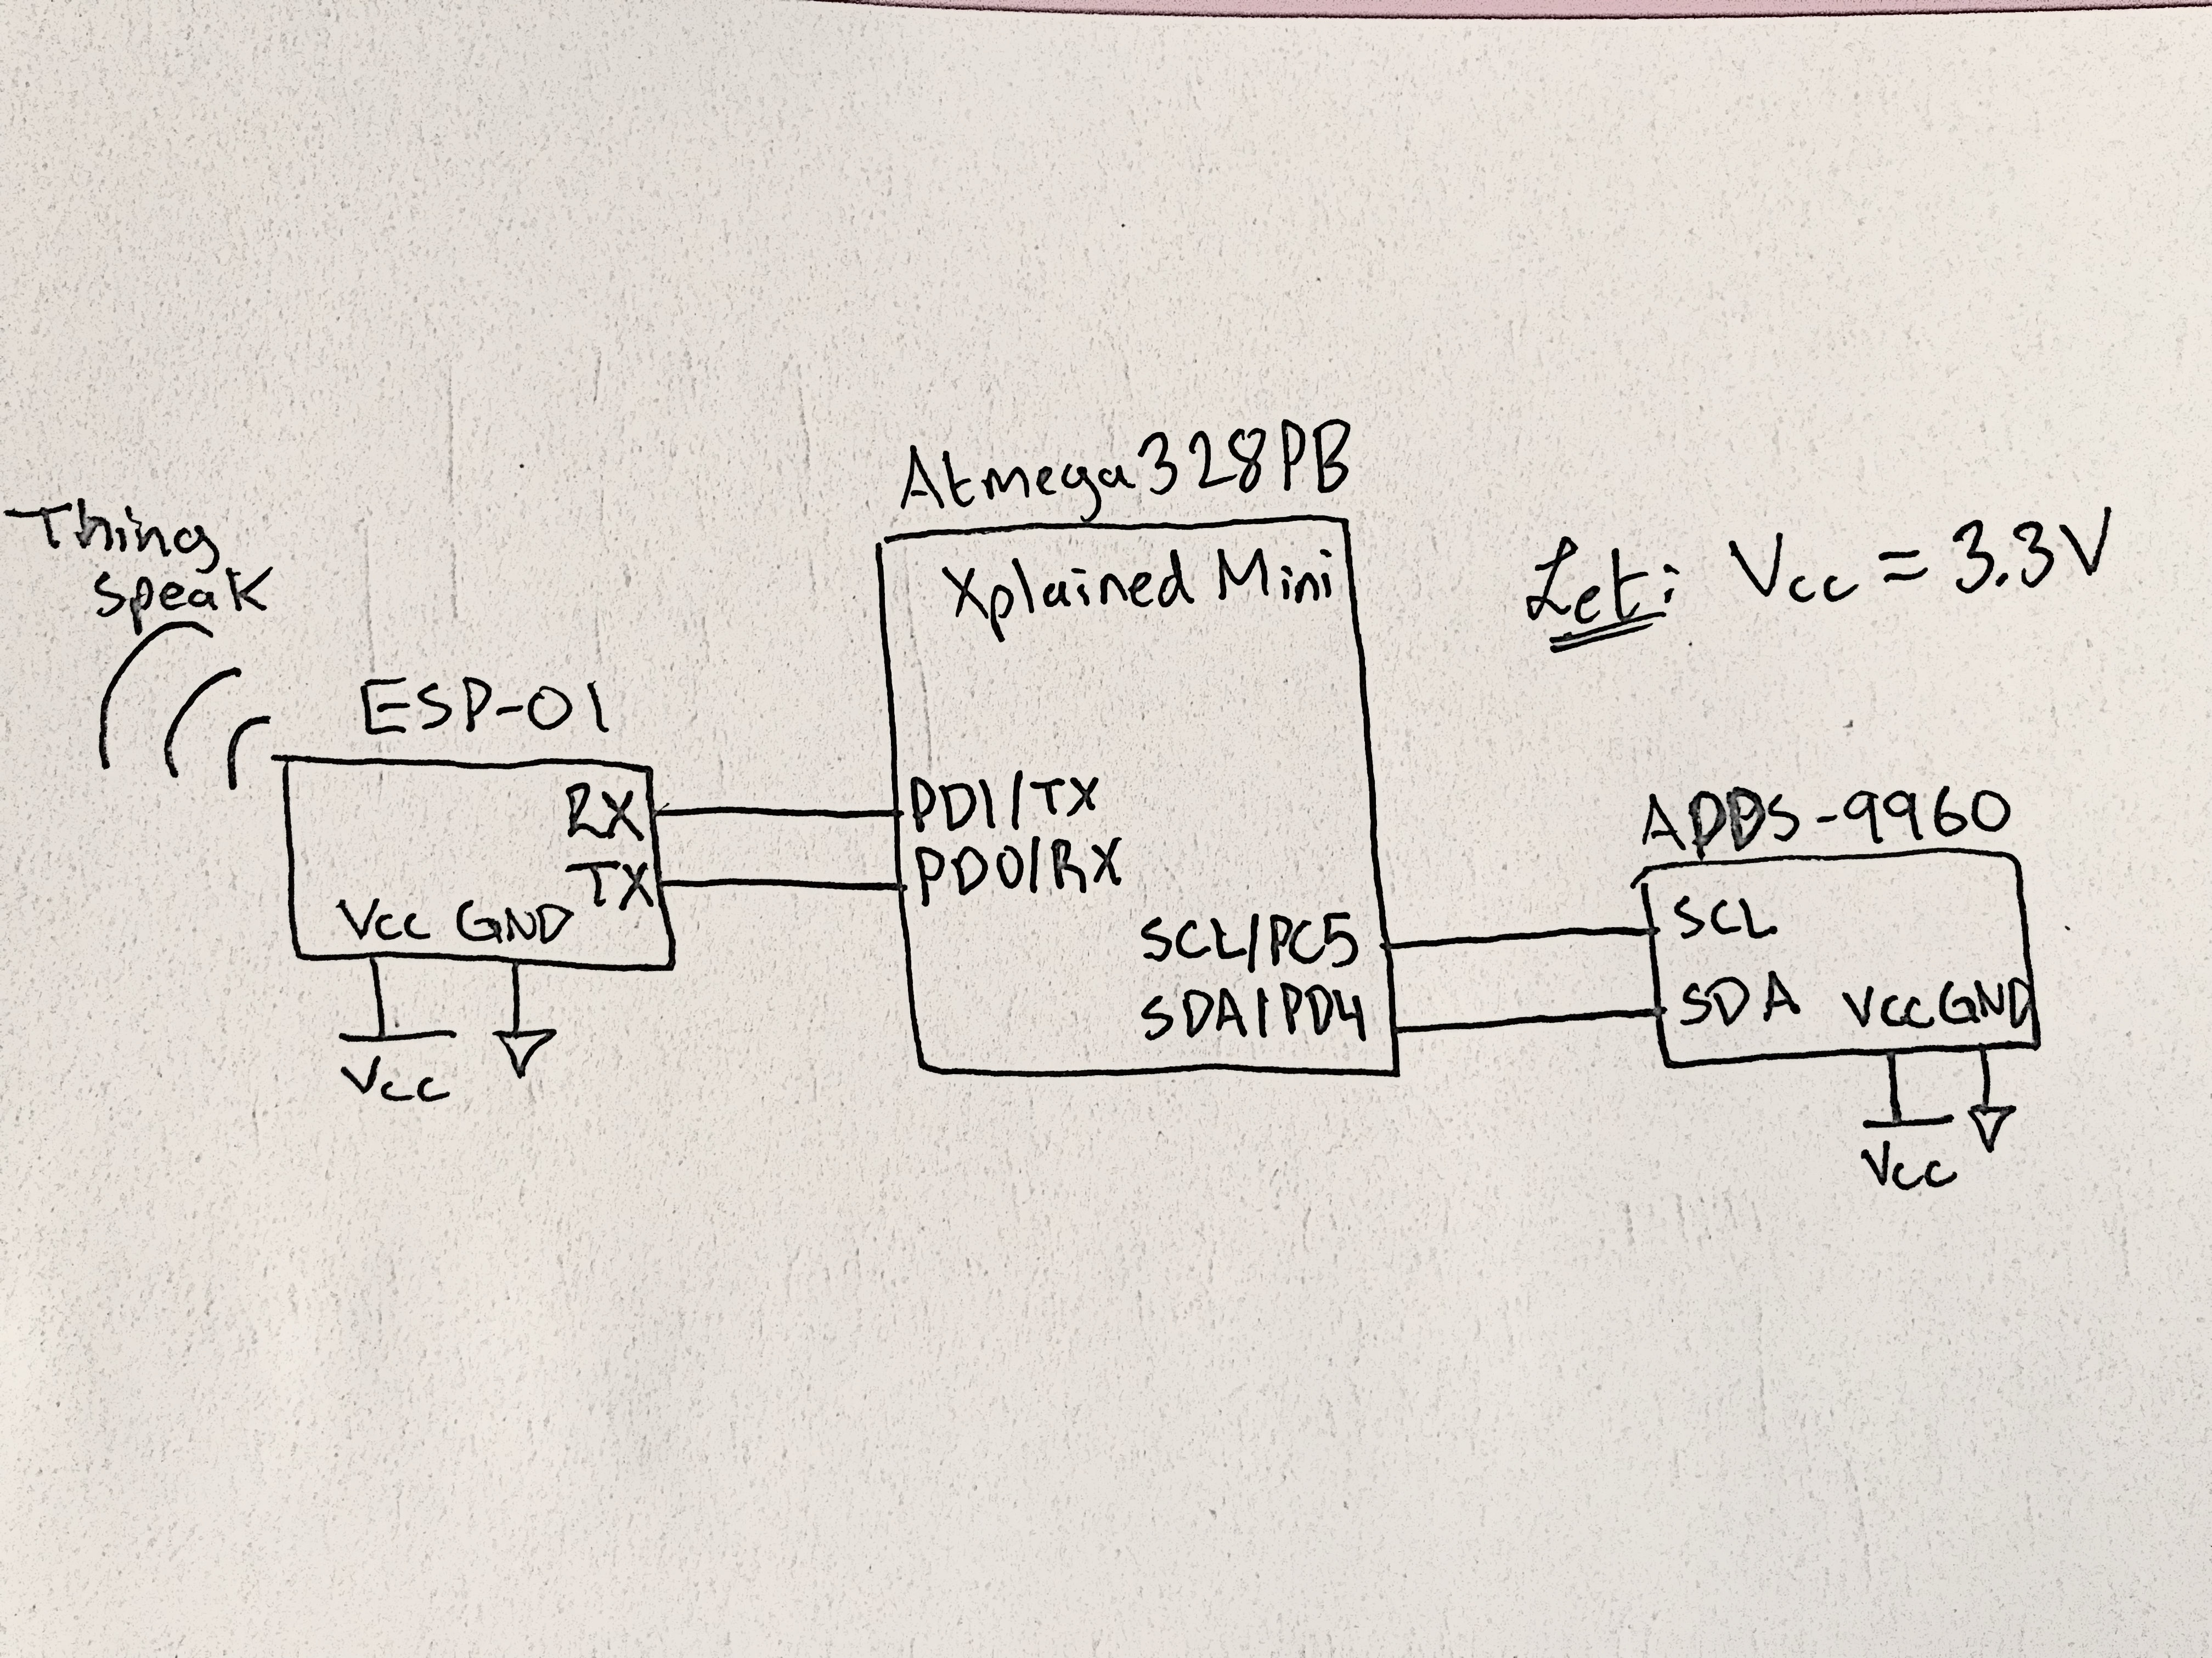

*Figure 2 – Schematic of APDS-9960 Connected to ESP-01*

1. **SCREENSHOTS OF EACH TASK OUTPUT (ATMEL STUDIO OUTPUT)**

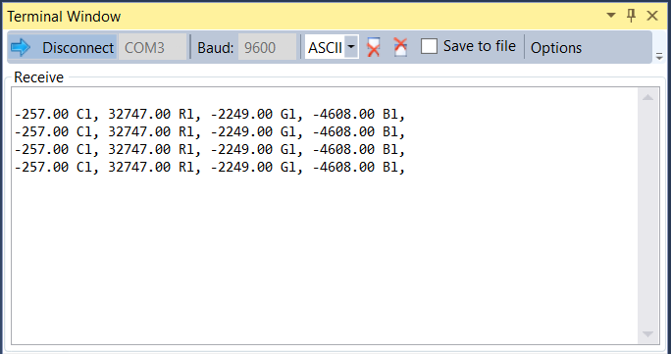

*Figure 3 – Output Terminal RGBC Values*

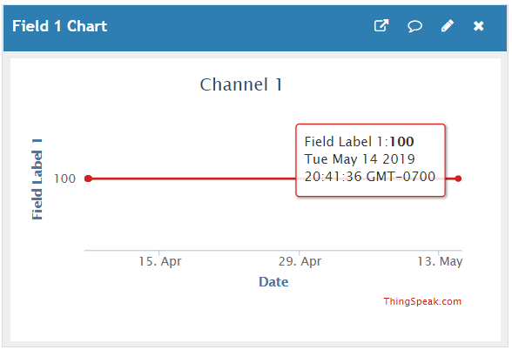

*Figure 4 – Output through ThingSpeak Practice Using Esplorer*

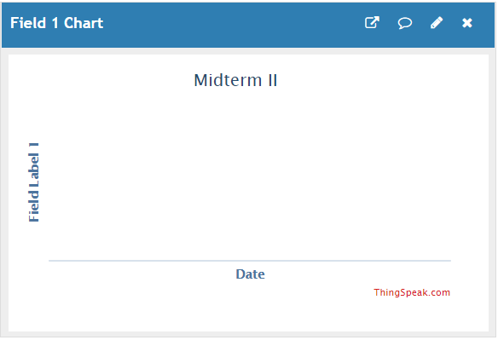

*Figure 5 – Output through ThingSpeak RGBC Reading*

1. **SCREENSHOT OF EACH DEMO (BOARD SETUP)**

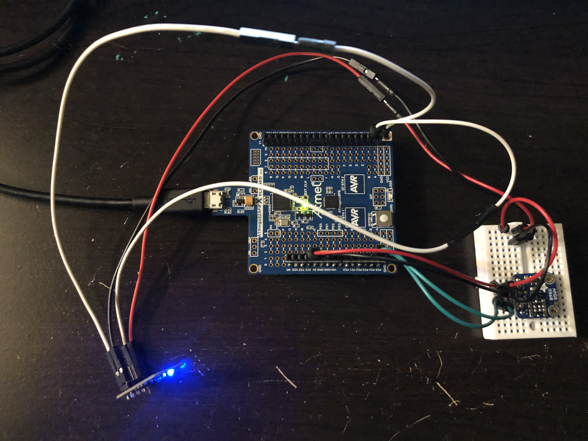

*Figure 6 – Board Setup for APDS-9960 Connected to ESP-01 Module*

1. **VIDEO LINKS OF EACH DEMO**

https://youtu.be/WiNJATyUzM0

1. **GITHUB LINK OF THIS DA**

https://github.com/rockyg1995/ihswppdar/tree/master/Midterms/Midterm_II

**Student Academic Misconduct Policy**

<http://studentconduct.unlv.edu/misconduct/policy.html>

“This assignment submission is my own, original work”.

Rocky Yasuaki Gonzalez